Project_3
Amazon Sales Data Analysis

Objective
The main objective of this project is to analyze Amazon sales data using Python and identify important sales and revenue patterns. The project focuses on calculating total revenue, identifying the best-selling products, analyzing city-wise and category-wise sales performance, and understanding monthly sales trends. The analysis helps transform raw sales data into meaningful business insights for better decision-making.

Scenario
An online Amazon sales business has collected sales transaction data containing information such as order date, product, category, city, quantity, and price. The business wants to understand its sales performance and identify the products, cities, and categories contributing to revenue.
Using Python, Pandas, and Matplotlib, the sales data is cleaned, processed, analyzed, and visualized. The analysis helps the business understand customer demand, revenue performance, city-wise sales, category contribution, and monthly sales trends. Based on these findings, useful business insights and recommendations are provided.

Part 1 — Data Loading

Task 1 — Import Required Libraries :-
import pandas as pd
import matplotlib.pyplot as plt

Task 2 — Load CSV Dataset :-
df = pd.read_csv("amazon_sales.csv")
Output:
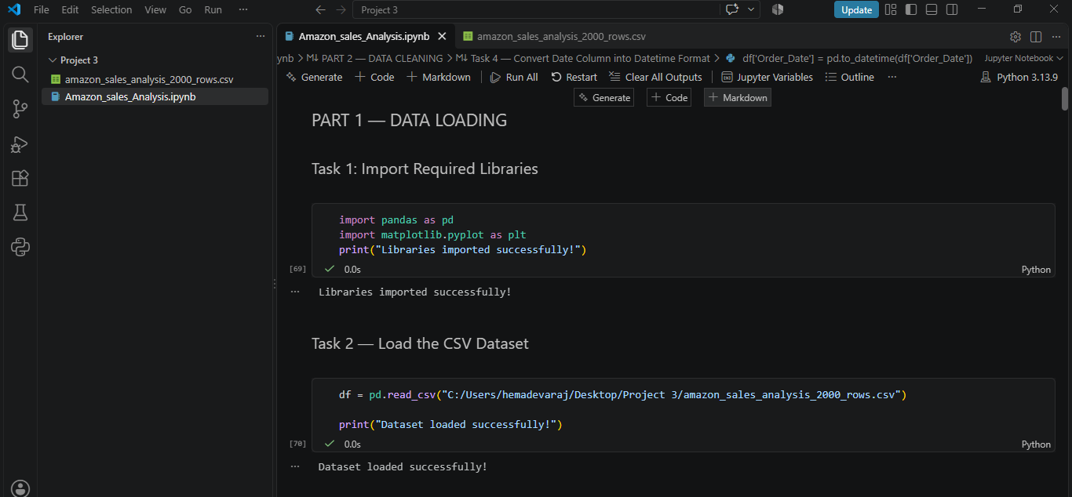

Task 3 — Display First 5 Rows :-
df.head()
Output:
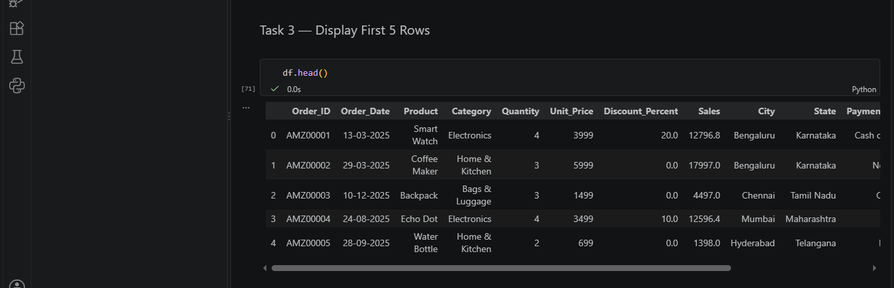

Task 4 — Check Dataset Information :-
df.info()
Output:
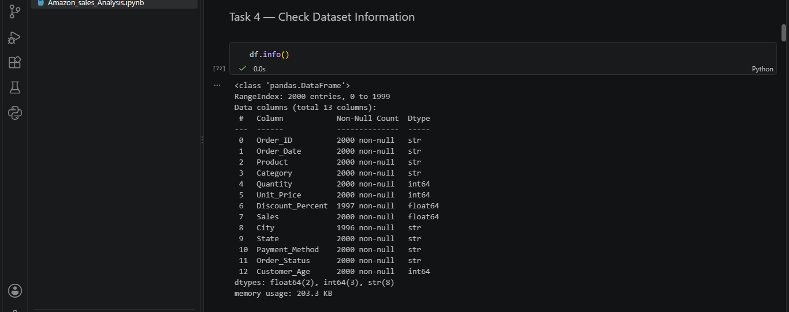

Part 2 — Data Cleaning

Task 1 — Check Missing Values :-
df.isnull().sum()
Output:
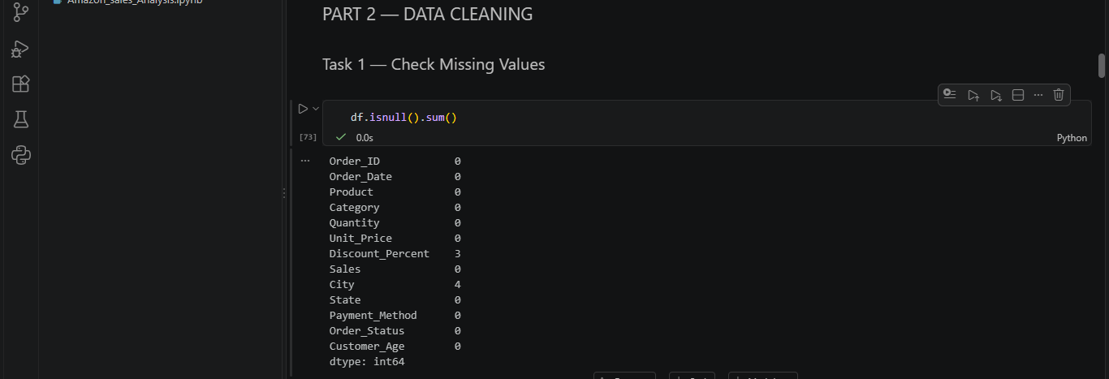

Task 2 — Check Duplicate Records :-
df.duplicated().sum():-
Output:
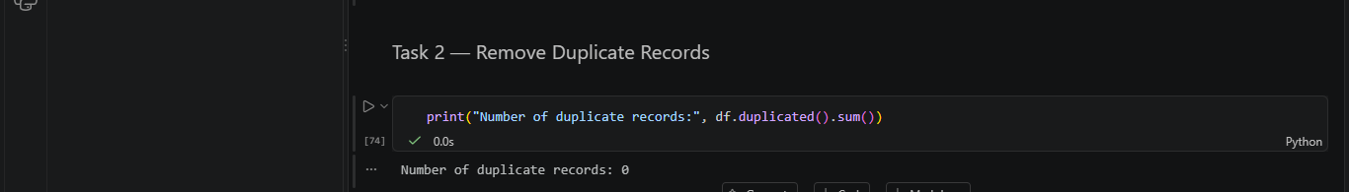

Task 3 — Check Spelling Errors :-
print("Products:")
print(df['Product'].unique())
print("\nCategories:")
print(df['Category'].unique())
print("\nCities:")
print(df['City'].unique())
Output:-
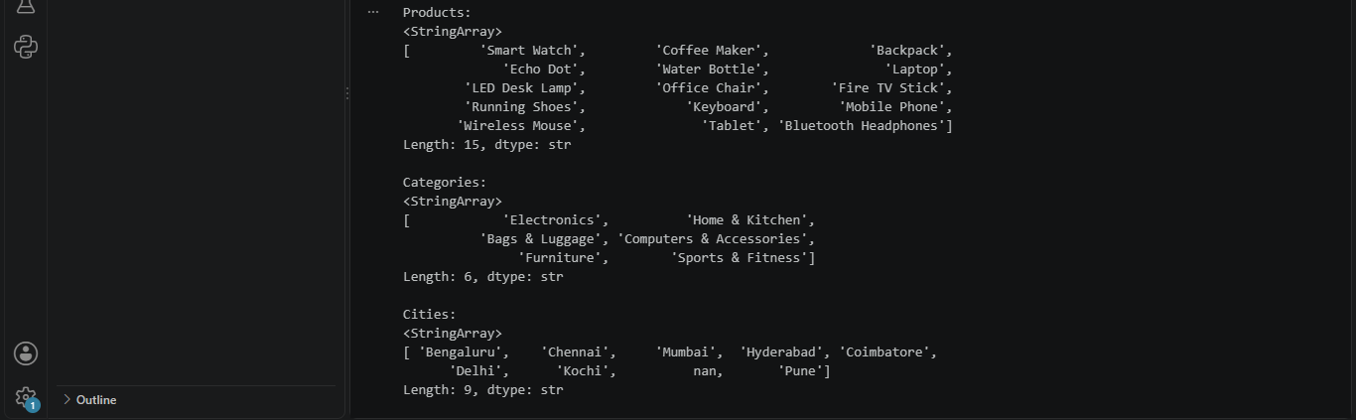

Task 4 — Convert Date Column into Datetime Format:-

df['Order_Date'] = pd.to_datetime(df['Order_Date'])
print(df['Order_Date'].dtype)
Output :-
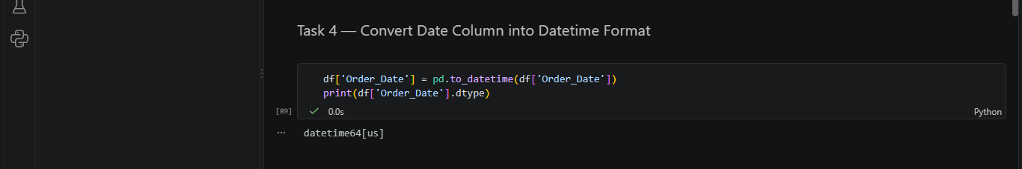

Part 3 — Data Processing
Task 1 — Create New Revenue Column :-
df['Revenue'] = df['Quantity'] * df['Price']
Output :-
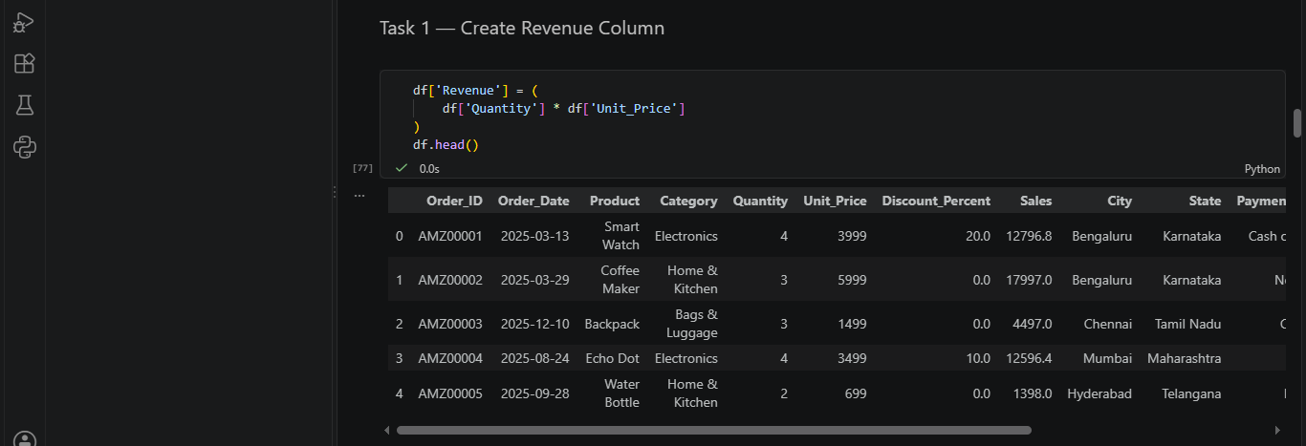
Task 2 — Add and Display Revenue Column :-
df.head()
Output :-
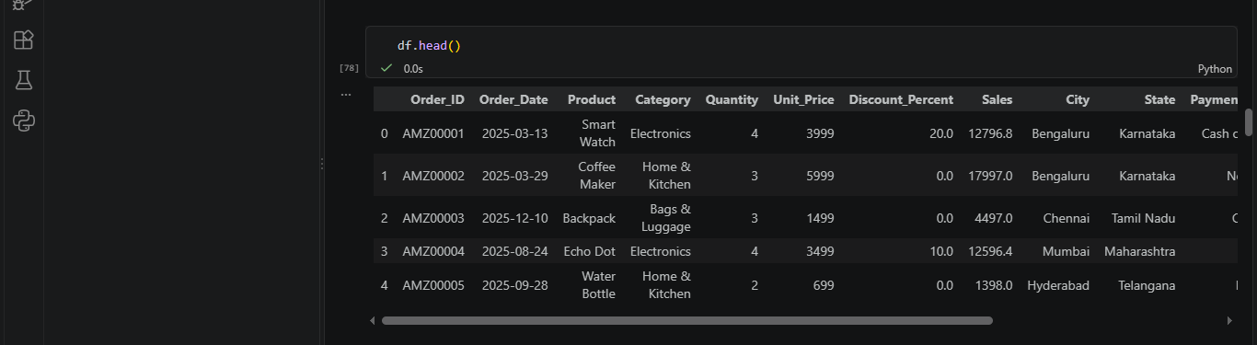
Task 3 — Check Revenue Column :-
print(df[['Quantity', 'Price', 'Revenue']].head())

Output:-
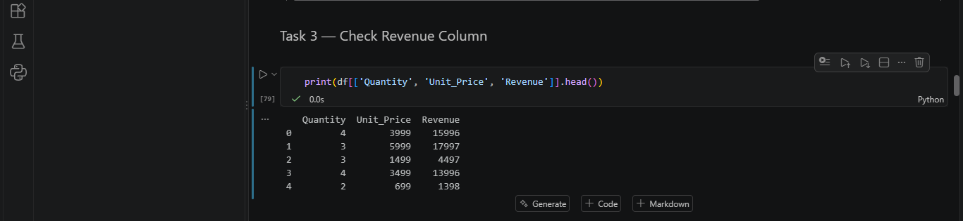

Task 4 — Check Revenue Information :-
print(df['Revenue'].describe())

Output :-
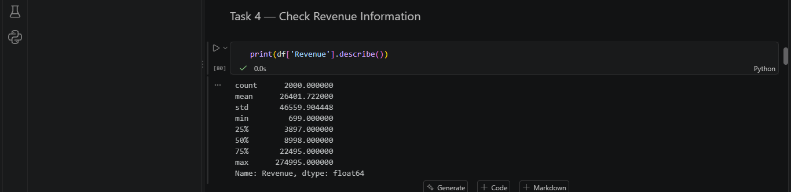

Part 4 — Data Analysis

Task 1 — Calculate Total Revenue :-

total_revenue = df['Revenue'].sum()

print("Total Revenue:", total_revenue)

Output :-

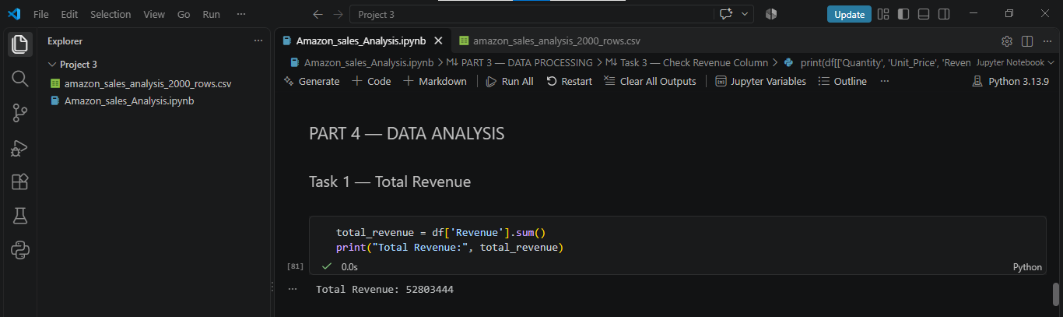

Task 2 — Best Selling Product :-

product_quantity = df.groupby('Product')['Quantity'].sum()
print(product_quantity)
Output :-
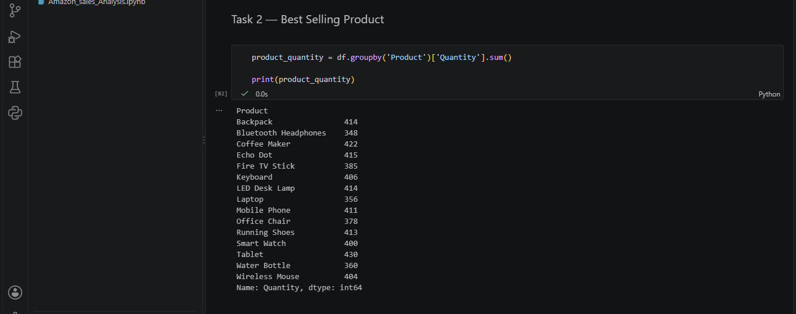
Task 3 — Best Performing City :-

city_revenue = df.groupby('City')['Revenue'].sum()
print(city_revenue)
Output :-
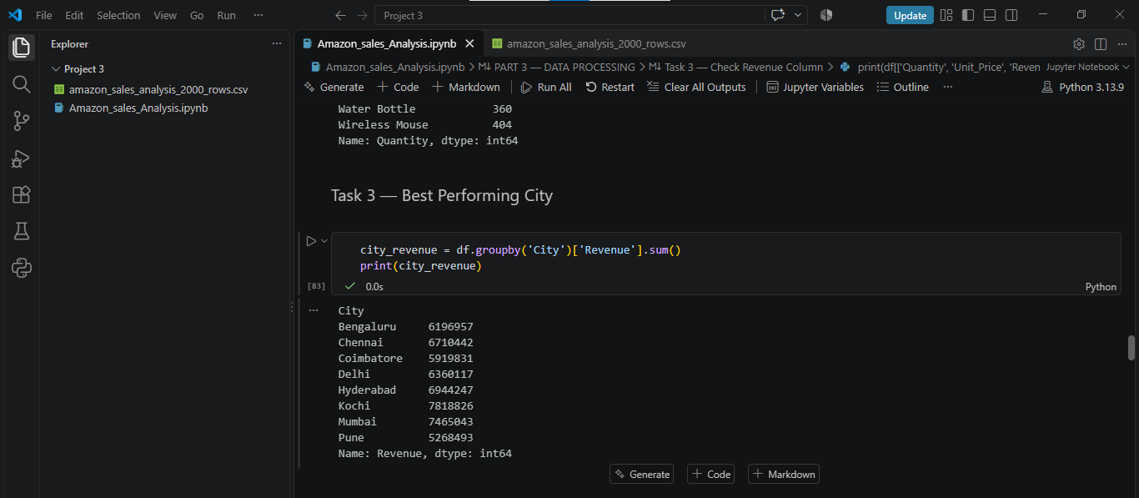

Task 4 — Category Analysis :-
category_revenue = df.groupby('Category')['Revenue'].sum()
print(category_revenue)
Output :-
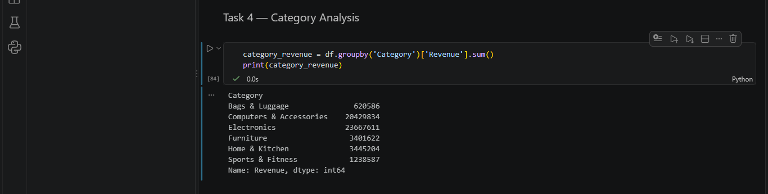
Task 5 — Monthly Sales Analysis :-

df['Month'] = df['Order_Date'].dt.to_period('M')
monthly_revenue = df.groupby('Month')['Revenue'].sum()
print("Monthly Revenue:")
print(monthly_revenue)

Output :-
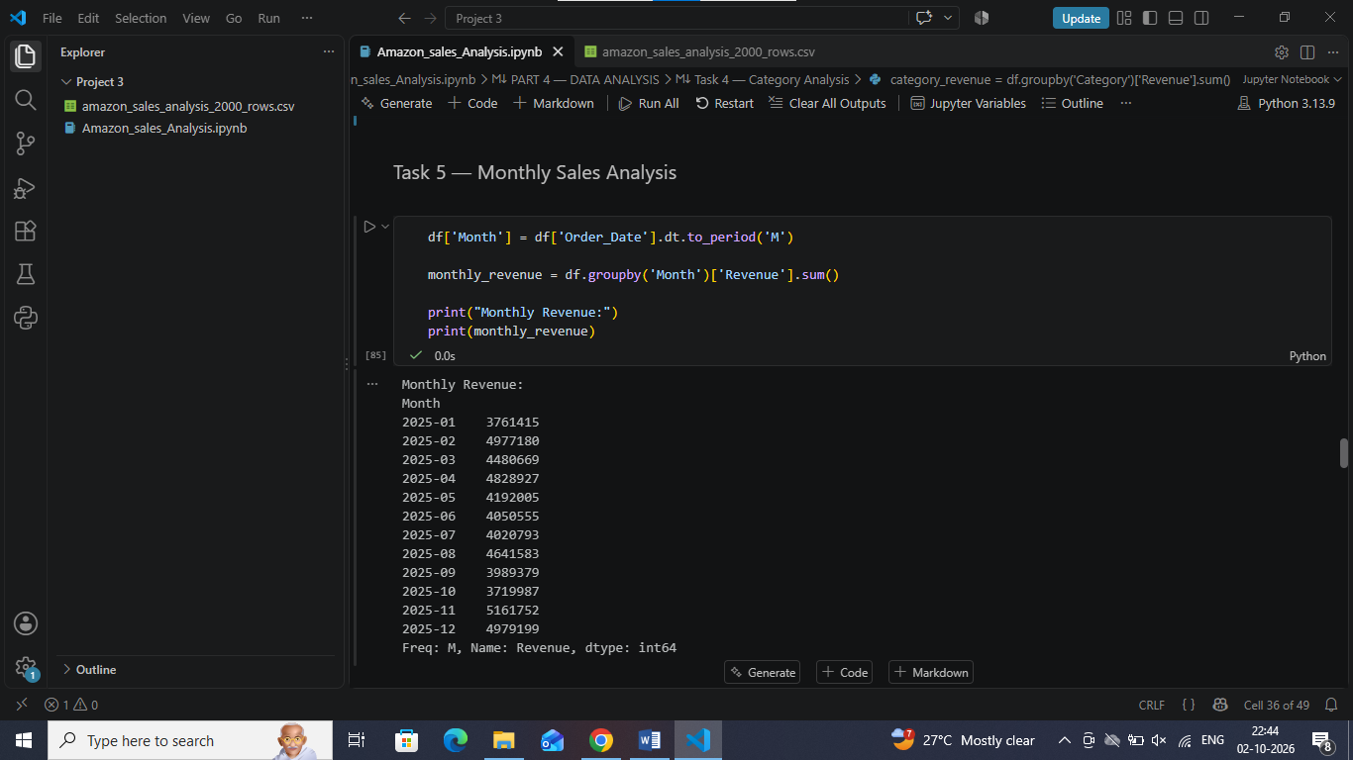
Part 5 — Data Visualization

Task 1 — Create Bar Chart for Revenue by City :-

plt.figure(figsize=(8, 5))
plt.bar(city_revenue.index, city_revenue.values)
plt.title('Revenue by City')
plt.xlabel('City')
plt.ylabel('Revenue')
plt.xticks(rotation=45)
plt.tight_layout()
plt.show()

Output :-

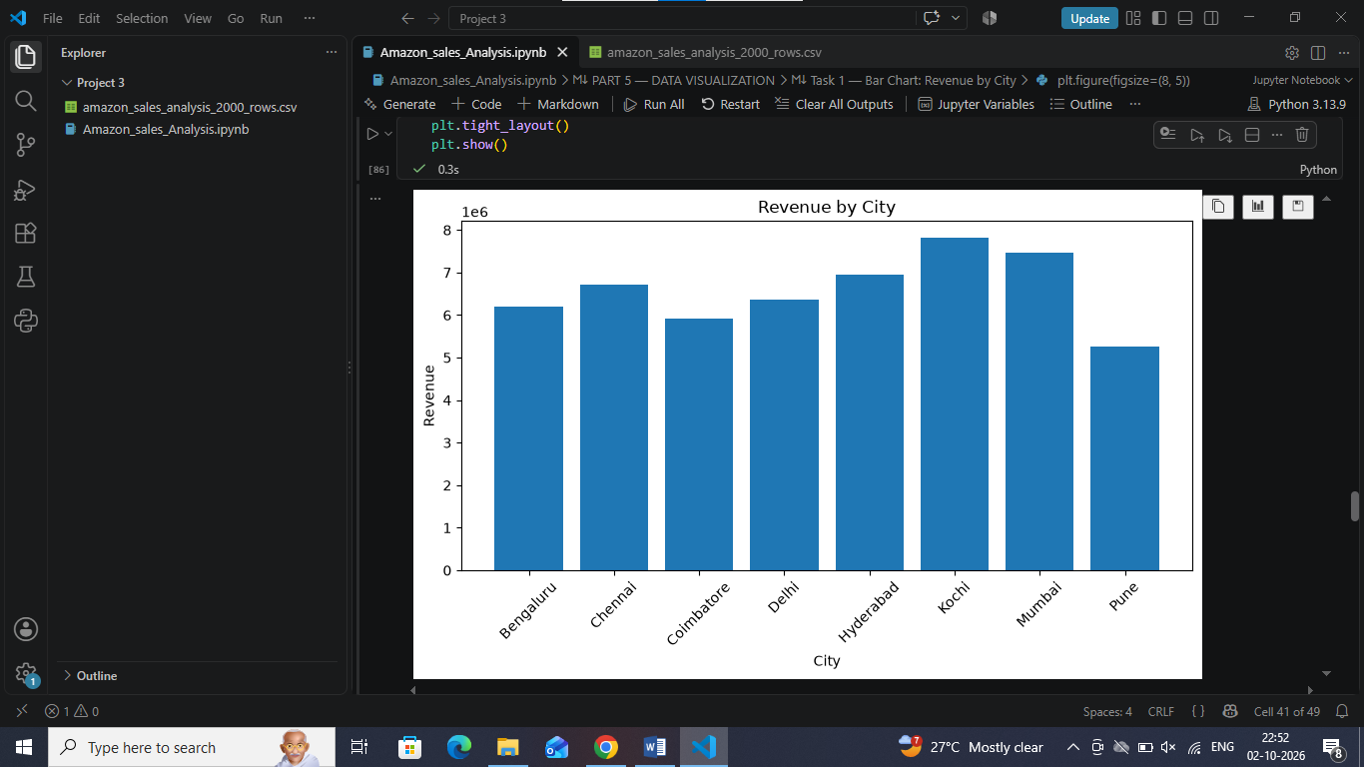

Task 2 — Create Pie Chart for Category Contribution :-

plt.figure(figsize=(7, 7))
plt.pie(
category_revenue.values,
labels=category_revenue.index,
autopct='%1.1f%%',
startangle=90
)
plt.title('Category Contribution to Total Revenue')
plt.tight_layout()
plt.show()

Output :-
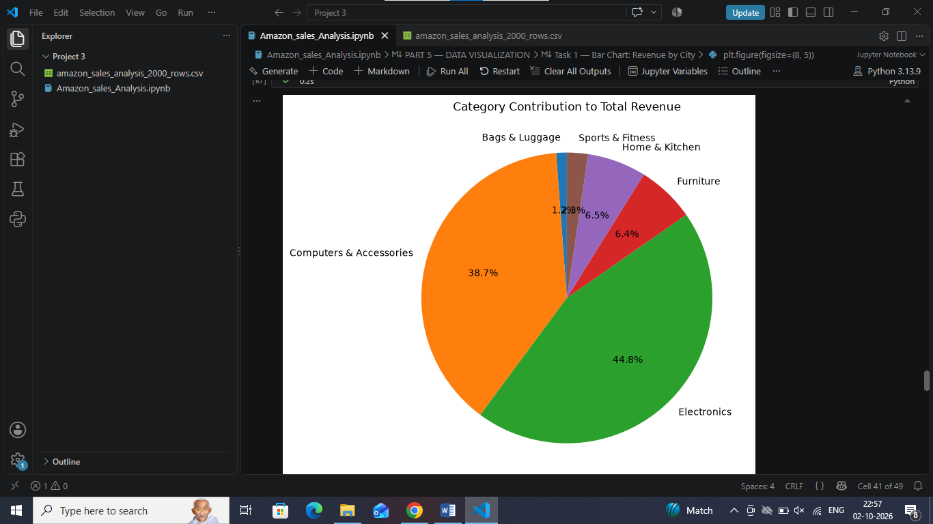

Task 3 — Create Line Chart for Monthly Sales Trend :-

df['Month'] = df['Order_Date'].dt.to_period('M')
monthly_revenue = df.groupby('Month')['Revenue'].sum( )
print("Monthly Revenue:")
print(monthly_revenue)
plt.figure(figsize=(10, 5))
plt.plot(
monthly_revenue.index.astype(str),
monthly_revenue.values,
marker='o'
)
plt.title('Monthly Sales Trend')
plt.xlabel('Month')
plt.ylabel('Revenue')
plt.xticks(rotation=45)
plt.tight_layout()
plt.show()

Output :-

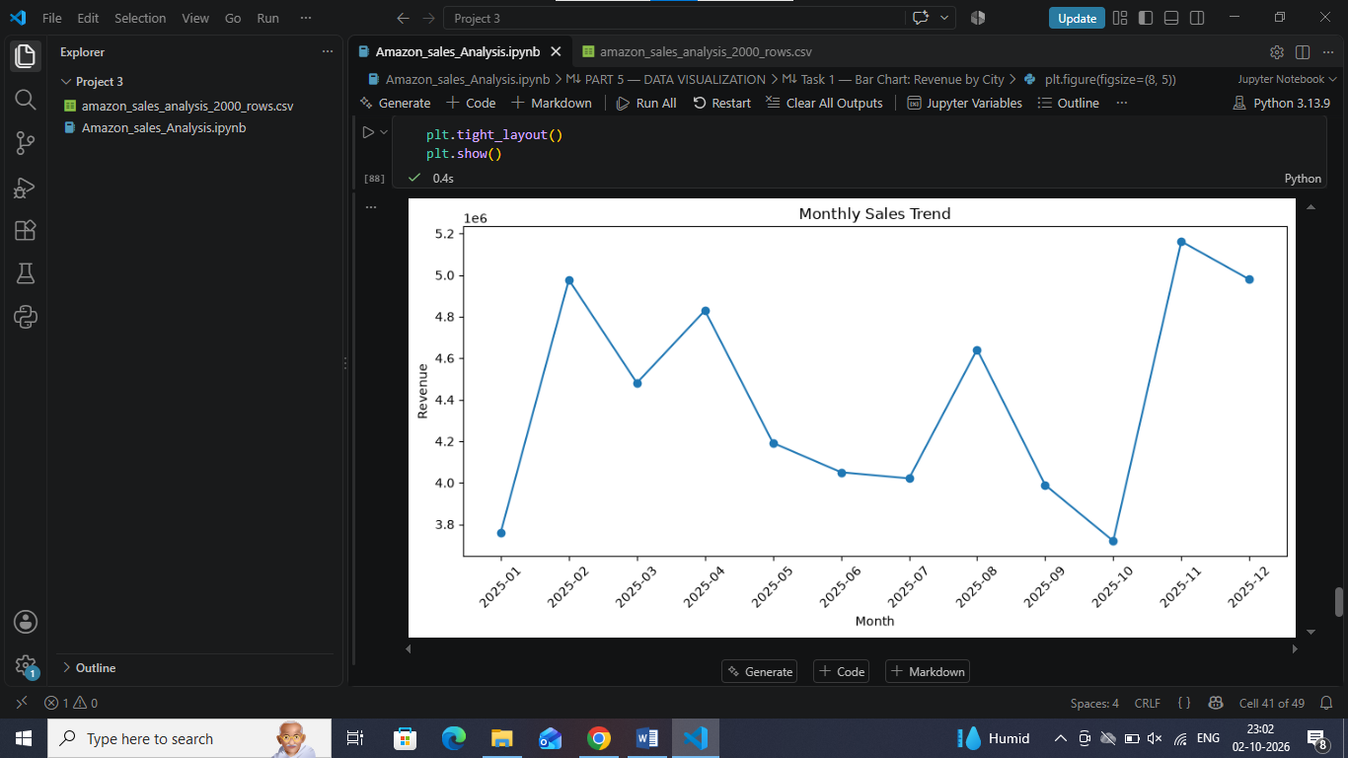

Part 6 — Business Insights

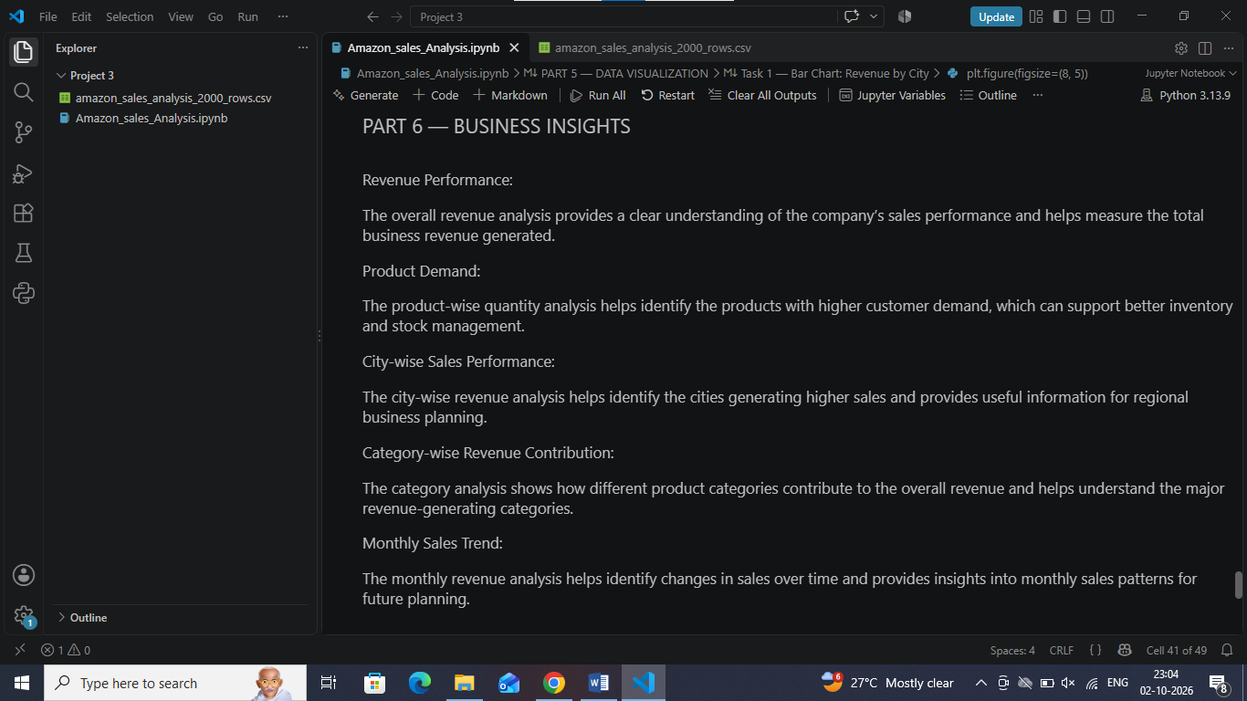

Part 7 — Recommendations

